Contact: Cheryl B. Kuhn, IOM
President & CEO
ckuhn@scccc.com
610.444.0774 (office) 610.209.2325 (mobile)

Alyssa Hupchick
Communications & Events Manager
ahupchick@scccc.com

SCCCC Recognizes Outstanding Service
at 2023 Annual Meeting Breakfast

January 24, 2023…West Grove, PA – The Southern Chester County Chamber of Commerce kicked off the year with clear and actionable goals, at its Annual Meeting, during which the 2023 Board of Directors was introduced. Speakers included Tim Moore, Immediate Past Chairman who shared strategic accomplishments and initiatives, Doug Doerfler, 2023 Chairman shared his vision and objectives, and President & CEO, Cheryl Kuhn recognized outstanding service of Members. More than 75 members and guests attended the event held on January 19th, at Hartefeld National Golf Club.

The business of the Chamber included the official Passing the Gavel from 2022 Chairman of the Board, Tim Moore (Constellation Energy), to 2023 Chairman of the Board, Doug Doerfler, SPHR (WSFS Bank). As Moore reflected on 2022, he named it a year to “Grow, Adapt and Prosper.” Moore noted the Chamber’s work with ChristianaCare, and he presented a call to action for members to get involved in committees as an invaluable way to do business and move the organization forward.

As 2023 Chairman of the Board, Doug Doerfler, SPHR (WSFS Bank) received the official gavel, he shared his excitement for the opportunity to again serve as Chairman. Doerfler previously served in 2018, and so he is well versed and ready to carry out the vision for a value-driven year to Lead, Educate, Connect and Advocate. The organization’s three main objectives for 2023 are to implement the Member Roadmap which will provide a more targeted path for Members; to enhance the Chamber’s mission through continued partnerships with business organizations, non-profits, local, state and federal officials; and to continue on the path as a leader in community efforts such as the Southern Chester County Digital Equity Coalition, Kennett High School’s Degree Program, County-wide Workforce Development & Training, and more.

Recognizing individual members for their valuable contributions is an essential part of what SCCCC stands for. The 2022 Presidents of the Chamber’s three Referral & Networking Groups were recognized for leadership and service: Ed Rahme, (Ed Rahme Architect), of BizNet; Kim Marucci, (Leading Forward), of CONNECTIONS, and Jonathan Orose, (Jonathan P. Orose - Springer Realty Group), of G.R.O.W. Presidents are elected annually by group members. They are tasked with directing 24 sessions over the course of the year where participants network and exchange referrals, hold member presentations, and provide opportunities to build their organizations through education.
The Chamber presented Eric Kuhn, Board Member (Pillar Real Estate Advisors, LLC), as “Volunteer of the Year” for delivering outstanding service and support to the Chamber in 2022, and, Houston Baker, Fulton Bank Brandywine Division, received “Closer of the Year,” for successfully bringing in the most new members over the previous 12 months.
“We are proud to present awards to our Members who volunteer and support the Chamber”, shared Cheryl B. Kuhn, President & CEO. She continued, “Members who can make time for us while they conduct business is an invaluable asset. Their passion and commitment allows us to thrive as an invaluable resource across Southern Chester County and beyond.”

For information on upcoming programs & events, or to learn more about the Southern Chester County Chamber of Commerce, visit www.scccc.com.

About Southern Chester County Chamber of Commerce
The Southern Chester County Chamber of Commerce, the region's leading pro-business member organization, is dedicated to the growth and development of its members and the business community by providing opportunities to connect organizations and support sustainable economic development. Founded in 1929 in Kennett Square, Pennsylvania, the Chamber’s nearly 500 member businesses consist of influential business leaders and professionals, not-for-profits, institutions, legislative leaders, and more. The Chamber hosts more than 70 events and programs each year across the Southern Chester County region. To join or learn more, visit www.scccc.com.

###

Photo Credit: Pam Hesler and Associates Photography, www.PamHeslerPhoto.com

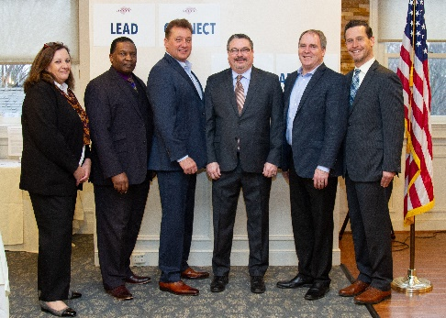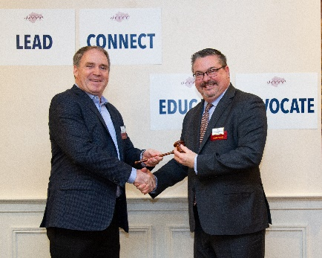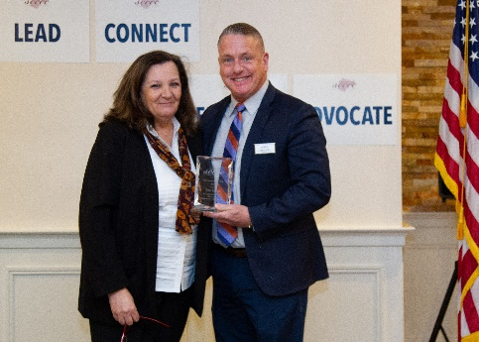

Photo Captions: (L to R)
1. Cheryl B. Kuhn, President & CEO, SCCCC ; 2020 Chairman of the Board, James E. Turner, Chester Water Authority ; 2015 Chairman of the Board Anthony J. Poluch, Jr., UNIVEST; 2018 & 2023 Chairman of the Board, Doug Doerfler, SPHR, WSFS Bank ; 2022 Chairman of the Board, Tim Moore, Constellation Energy ; 2019 Chairman of the Board Erik Gudmundson, Pegasus Technologies, LLC

2. 2022 Chairman of the Board, Tim Moore, Constellation Energy ; 2023 Chairman of the Board, Doug Doerfler, SPHR, WSFS Bank

3. Cheryl Kuhn, President & CEO of SCCCC ; 2023 Volunteer of the Year, Eric Kuhn, Pillar Real Estate Advisors, LLC

