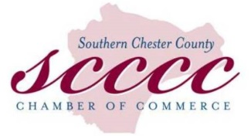
For further information, contact:
Beth Krallis,
Marketing & Communications Officer
Chester County Community Foundation
bethk@chescocf.org (484) 887-0467

CHESTER COUNTY COMMUNITY FOUNDATION PROUD
TO ANNOUNCE NEW EDUCATION & SCHOLARSHIP FUND
Southern Chester County Chamber of Commerce Created
Fund to provide Scholarships to local high school students
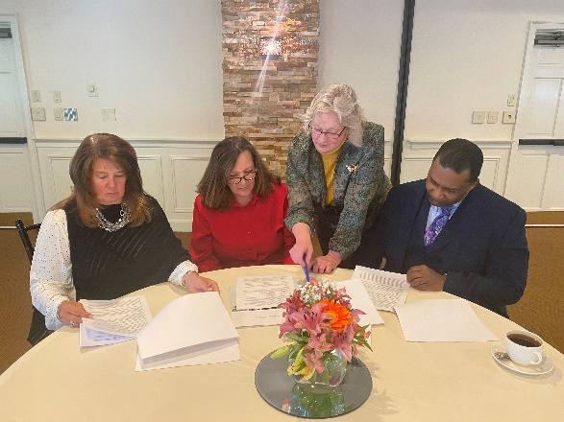

(WEST CHESTER, PA – July 13, 2021): The Chester County Community Foundation (CCCCF) is pleased to announce the creation of a new fund created by the Southern Chester County Chamber of Commerce (SCCCC). The fund agreement was signed by members of the Chamber leadership and Chester County Community Foundation staff at the clubhouse at Hartefeld National, a premier golf club located in Avondale.

The SCCCC Education & Scholarship Fund will offer education and scholarship funds to graduating high school seniors in the Chamber’s service area: Avon Grove, Kennett Square, and Unionville. This includes Chester County Technical College High School–Pennock’s Bridge Campus. Scholarships will also be awarded to Southern Chester County high school students attending Pennsylvania Free Enterprise Week (PFEW), a week-long action-filled entrepreneurial camp developed by the Foundation for Free Enterprise Education. The Chamber will allocate proceeds from fundraising events and donations to its Education & Scholarship Fund to support this commitment. Scholarships will range from $500 - $1,000.

Cheryl B. Kuhn, IOM, Chamber President & CEO says, “Our Chamber was founded almost 100 years ago and we are delighted by how much we have grown, changed, and adapted to support Southern Chester County’s businesses community. We are proud to be able to formally give back to our local students through educational scholarships. It is our goal to continue to support our local youth who are the future of the global business and non-profit world we live in.”

To make a tax-deductible donation, please visit https://chescocf.org/fund/scccc-fund/ or send a donation to SCCCC Education & Scholarship Fund c/o The Chester County Community Foundation, 28 West Market Street, West Chester, PA 19382.

Photo caption (left to right): Betsy Niedziejko, Chairman of the Board of SCCCC, WSFS Bank; Cheryl B. Kuhn, IOM, President & CEO of SCCCC; Karen Simmons, President & CEO of CCCF; and James E. Turner, Immediate Past Chairman of SCCCC, Chester Water Authority.

***

About the Chester County Community Foundation

Headquartered in West Chester’s Lincoln Building, the Chester County Community Foundation connects people who care with causes that matter so their legacy philanthropy makes a difference now and forever. The Community Foundation holds nearly $70 million in trust and annually awards $3.5 million in grants and scholarships. To learn more about the Community Foundation, visit www.chescocf.org.

###
About Southern Chester County Chamber of Commerce

The Southern Chester County Chamber of Commerce, the region's leading pro-business member organization, is dedicated to the growth and development of its members and the business community by providing opportunities to connect businesses and support sustainable economic development. Founded in 1929 in Kennett Square, Pennsylvania, the Chamber’s nearly 500-member businesses consist of influential business leaders and professionals, not for-profits, institutions, legislative leaders, and more. The Chamber leads business and community initiatives that support our region and hosts more than 70 events and programs each year. To learn more about the Chamber, visit www.scccc.com.

###

